Name-Saiba Pathan
Rollno-09
Div-C
Lab 5

Lab Title:
Kubernetes on AWS using EKS (Elastic Kubernetes Service)
Deploying Applications to Kubernetes on AWS (EKS)
Objective:
Introduction to Amazon Elastic Kubernetes Service (EKS), create a cluster, deploy a containerized application, and manage it using kubectl.
Duration:
2.5 – 3 hours
Pre-requisites:
- AWS Free Tier account with EKS, IAM, EC2, and VPC access
- Completed Lab 3 (Docker image pushed to ECR)
- AWS CLI v2, kubectl, and eksctl installed (CloudShell can be used with adjustments)

Part A: Setup Kubernetes Tools (20 mins)
1. Launch AWS CloudShell
aws --version kubectl version --client eksctl version
If kubectl or eksctl is missing:
curl -LO https://github.com/weaveworks/eksctl/releases/latest/download/eksctl_$
(uname -s)_amd64.tar.gz mkdir -p ~/bin && tar -xzf eksctl_*.tar.gz -C ~/bin && export PATH=$PATH:~/bin
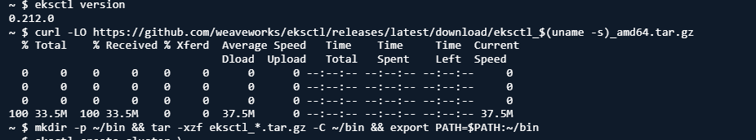

Part B: Create EKS Cluster (45 mins)
1. Create EKS Cluster using eksctl
eksctl create cluster \ --name demo-cluster \
--version 1.29 \
--region us-east-1 \
--nodegroup-name demo-nodes \
--node-type t3.small \
--nodes 2 \
--managed
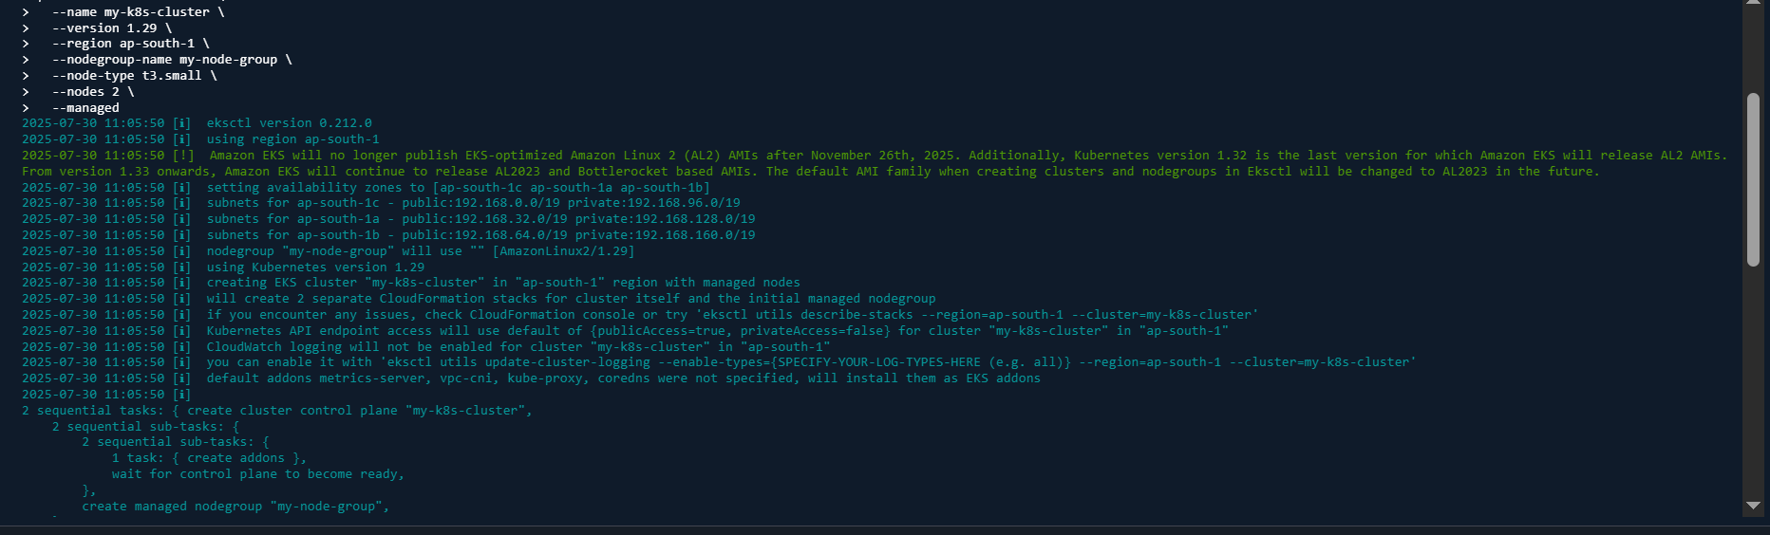
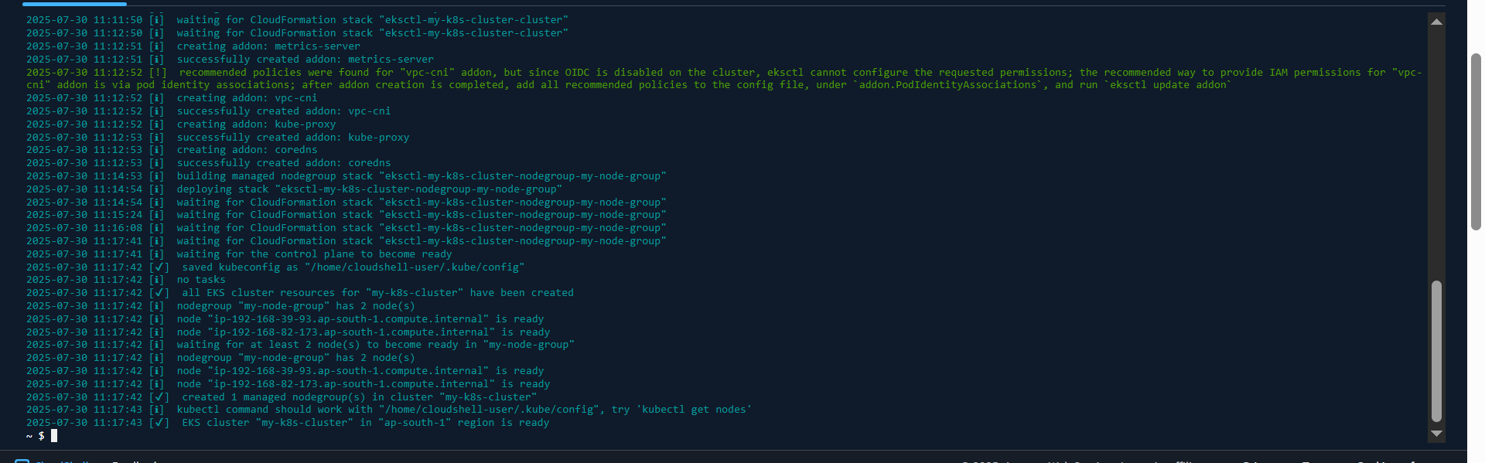
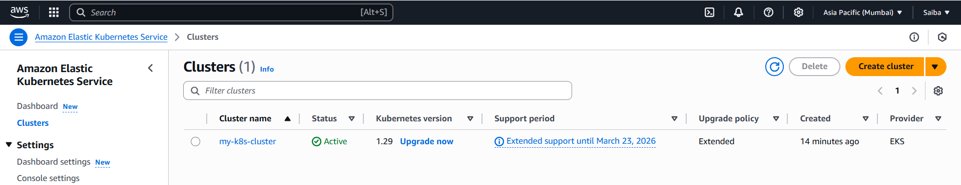
⚠️ This step takes ~10–15 minutes. It creates:
- A VPC
- EKS control plane
- Worker nodes (EC2)

Part C: Configure Access and Test Cluster (15 mins)
- Update kubeconfig to access the cluster aws eks --region ap-south-1 update-kubeconfig --name demo-cluster
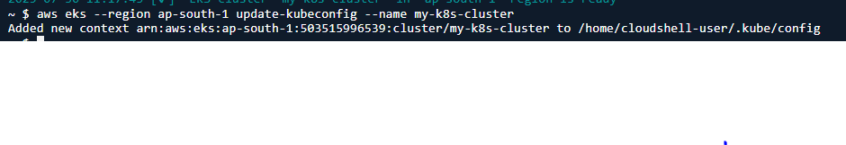
- Verify cluster access
kubectl get nodes kubectl get svc
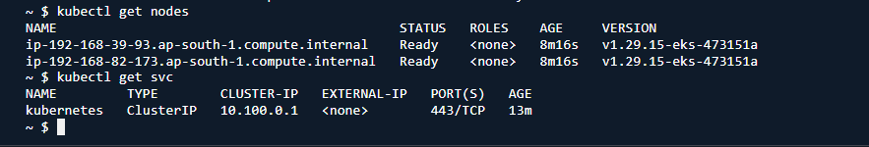

Part D: Deploy Your Container App (40 mins)
1. Create Deployment YAML file (use nano / vi)

#cat <<EOF > deployment.yaml
apiVersion: apps/v1 kind: Deployment metadata:
name: web-app spec: replicas: 2 selector: matchLabels: app: web template: metadata: labels: app: web spec: containers: - name: nginx
image: 503515996539.dkr.ecr.ap-south-1.amazonaws.com/sample-webapp:latest ports: - containerPort: 80

#EOF
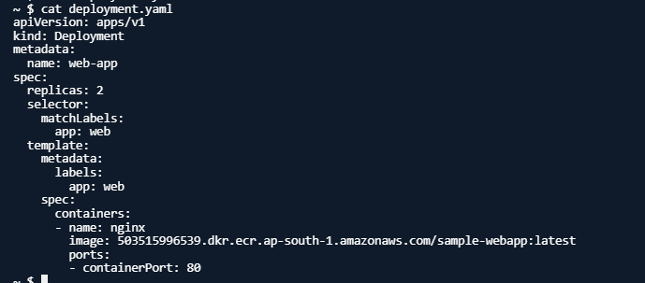
- Apply Deployment
kubectl apply -f deployment.yaml kubectl get deployments
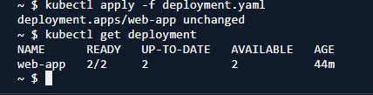
- Expose the Deployment
kubectl expose deployment web-app --type=LoadBalancer --port=80
- Get External IP (may take a few minutes) kubectl get svc web-app



Use the EXTERNAL-IP to open the deployed app in your browser.

Part E: Scale and Manage Pods (20 mins)
- Scale Deployment
kubectl scale deployment web-app --replicas=4 kubectl get pods
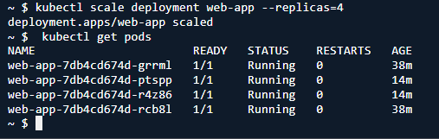
- Rollout an Update (Optional)
kubectl set image deployment/web-app nginx=<new-image> kubectl rollout status deployment/web-app
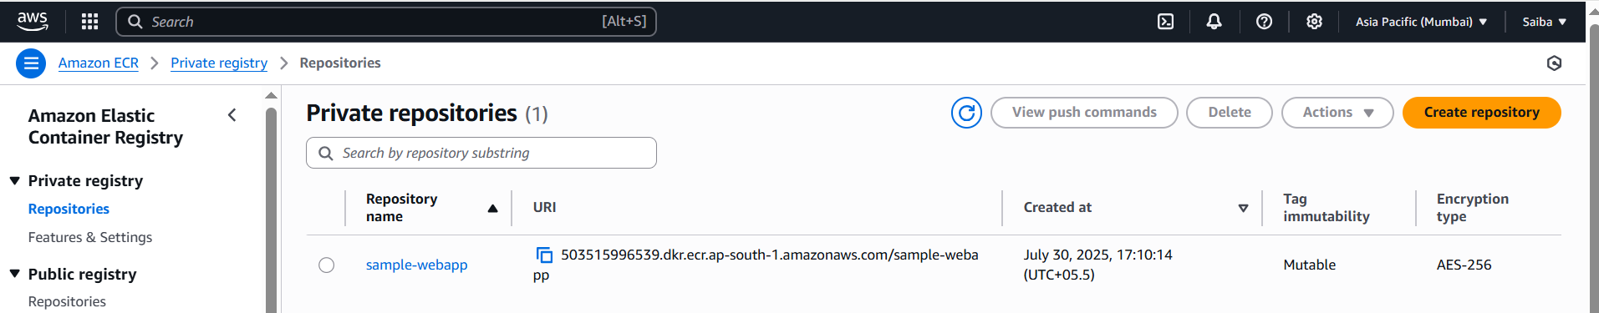

Part F: Clean-up (Optional)
- Delete Kubernetes resources
kubectl delete service web-app kubectl delete deployment web-app

- Delete EKS Cluster
eksctl delete cluster --name demo-cluster --region us-east-1
